Silent card Shuffle
Angle type | Comment | Diagram | Example
Add up to 90° | 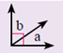 | 130° and 50° | Complementary
Opposite angles are equal | 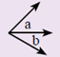 | 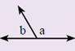 | Vertically opposite
Next to each other | Add up to 180° | When two lines cross | 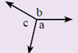
Have the same vertex and have a common arm | 30° and 60° | Adjacent | Angles sum to give 360°
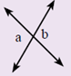 | Add up to 360° | Angles at a point | Supplementary

Silent card Shuffle
Angle type | Comment | Diagram | Example
Add up to 90° |  | 130° and 50° | Complementary
Opposite angles are equal |  |  | Vertically opposite
Next to each other | Add up to 180° | When two lines cross
Have the same vertex and have a common arm | 30° and 60° | Adjacent | Angles sum to give 360°
 | Add up to 360° | Angles at a point | Supplementary

